Derek Kniffin – CSCI 4229

First off, I am pulling a lot of this description from my "Who am I" assignment. I described it fairly well there, so I've copied that text, and changed it to reflect my thoughts and progress since then.

Before explaining my project, I need to explain some background components that will influence the project. That is the reason for the length of this description. Please bear with me...

# Background

Firstly, there's a collaborative project called OpenStreetMap (http://osm.org) (aka: OSM). Basically, it's an open-data map of the world. (Think google maps meets wikipedia). Unlike google maps, the data doesn't simply include roads and stores; it also includes lots of other features including: buildings (outlines, height, number of levels, etc), urban features (fire hydrants, stop lights, stop signs, etc), non-urban features (parks, forests, farmland, beaches, water, etc), and much more. The schema is meant to be able to map pretty much any physical object that doesn't move often. (ie: anything you might ever see on a map)

Next, there's a popular “rendering engine" for this map data, called Leaflet (http://leafletjs.com). Basically how that works, is you give it a URL in javascript, and it gets pre-rendered tiles (PNGs) from a web server and displays them next to eachother. Not much to it.

Screenshot of Leaflet rendering OSM data for campus: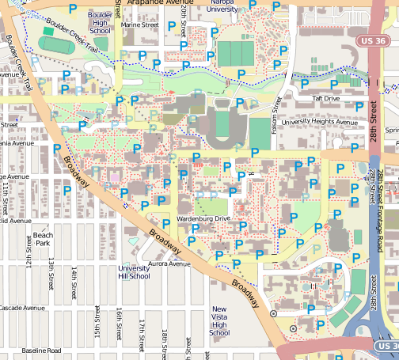

Now comes the interesting part. There's a plugin for Leaflet called OSMBuildings (http://osmbuildings.org/), which displays the building data from OSM in a 3D format. I've looked at the code for this plugin, and I've talked a bit with the developer of the project (a German guy). At the moment, he's rendering everything with the HTML5 canvas api.

Screenshot of osmbuildings rendering part of NYC:

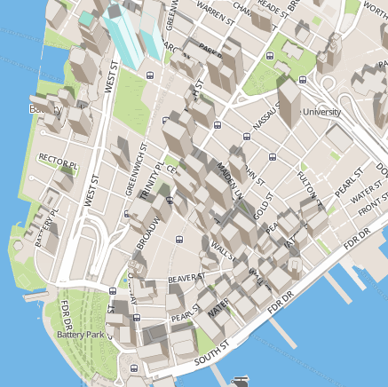

(Oh, by the way: all of the above is open-source)

# My Project

What I've decided to do is create something akin to Leaflet, but in 3D, and extend its capabilities a bunch. My original thought was that I'd fork OSMBuildings, but I've since decided against that, because my project is too extensive to be a plugin. It works better as its own project.

The goal is to create an open-source API so that anyone can clone it, give it some data, and generate a 3D scene. I would like to keep the API similar to Leaflet, so that users who are familiar with Leaflet will be able to use mine easily. The working name for this project is Berries (3d leaves?; suggestions welcome)

The project will be designed for the web. To make this project much easier, I will use three.js (the extensive webgl library). I also plan to load in pre-made models for many things (such as fire hydrants, flag poles, etc).

I plan to render many things in 3D. The ones I will definitely finish by the end of the semester are:

* Buildings
* Roads, footpaths, etc
* "Man made objects" (fire hydrants, flagpoles, bike racks, etc)
* Traffic signals
* Water features

Other features I will include as time permits:

* Forests
* Power lines
* Surfaces (dirt, gravel, paved, sand, grass, etc; represented as textures)
* Anything I can find on wiki.osm.org that looks relevant

I also plan to publish the code, so that anyone can add other features in the future if they'd like.

Additionally, the API will include an interface to include terrain data (SRTM is a good open-data source for this).

Some other lofty objectives I might try for, time permitting:

* Interactive capabilities (allow API users to add "onclick" functionality for features)
* Loading of custom objects (the API user can load a model of a character or something, and move it around in the environment)
* Lighting based on time at the realworld location of the model (lat/lon)
* Weather, based on internet APIs (openweathermap, wunderground, etc)

I have already made a lot of progress on this project, and I've gotten a lot done, including: terrain generation from SRTM data, roads (kinda buggy), and buildings (basic geometry is almost complete).

Here’s a screenshot of what I have so far: (in case you don’t recognize it, it’s the Engineering Center)

